2.1

Answer to following questions:

**• What is the purpose of the RWD?**

The web doesn’t have the design for the flexibility.

The purpose of RWD is to help the website to be more flexible in multiple platforms (mobile web browser, desktop web browser, etc.)

There are responsive architechtures like robotics and tensile materials, motion sensors

**Why it is used?**

Rather than creating immutable, unchanging spaces that define a particular experience, they suggest inhabitant and structure can—and should—mutually influence each other.

**How things are done before RWD?**

* straightforward two-column layout built on a [fluid grid](http://www.alistapart.com/articles/fluidgrids/), with not a few [flexible images](http://unstoppablerobotninja.com/entry/fluid-images) peppered throughout
* Using JS code

**What is the difference?**

* When open the websites on mobile, pictures are resized and stressed out and cropped. The flexible design works well enough in the desktop-centric context for which it was designed, but isn’t optimized to extend far beyond that.
* With RWD, we use media queries for this, and the websites will be responsive on different media screens, papers.

**• How css media queries can help you building responsive web sites?**

Base on media type and media features. CSS media queries also have screen resolution features. Using @media and @import rules.

**• Why to use em (font) based sizing for example margins?**

Using ‘em’ for sizing, we can reserve space relative to other things/ objects.

**• Article is already 7 years old, do we have any new technology which can  
be used to achieve same type of UI responsiveness as described in the  
article. Buzz words: (CSS Grid, Flexbox)**

2.2

1. Bostonglobe.com

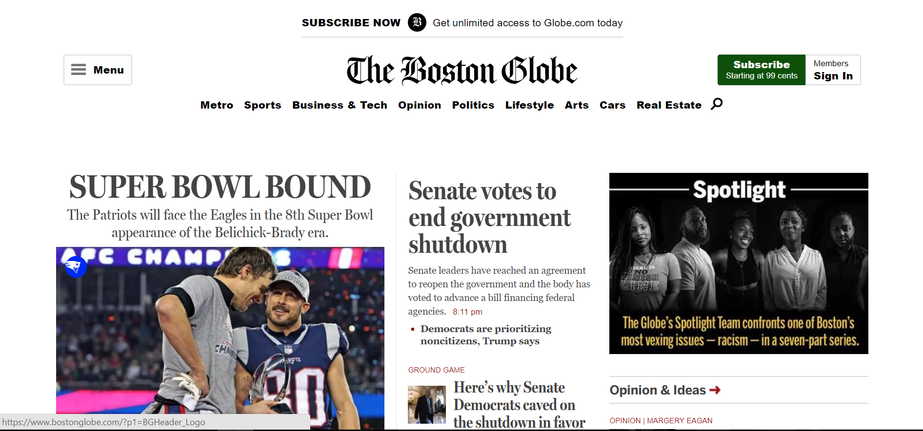

on laptop screen 900x480 px

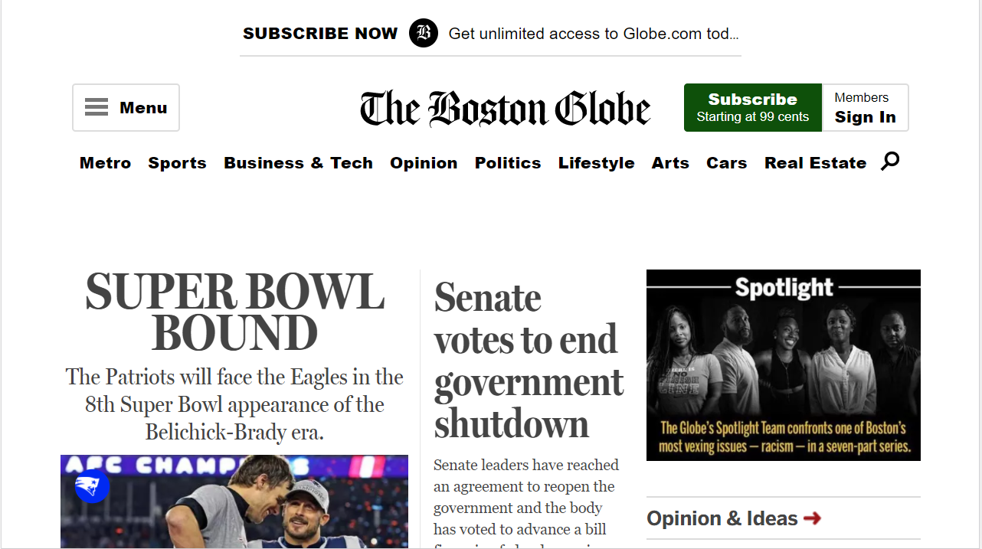

On screen 851x480 px



On screen 360x640 px

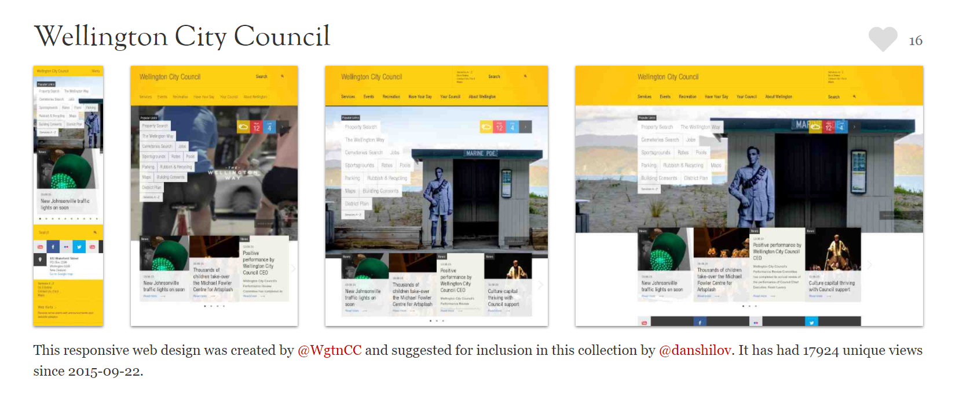

Wellington City Council webpage on different screens

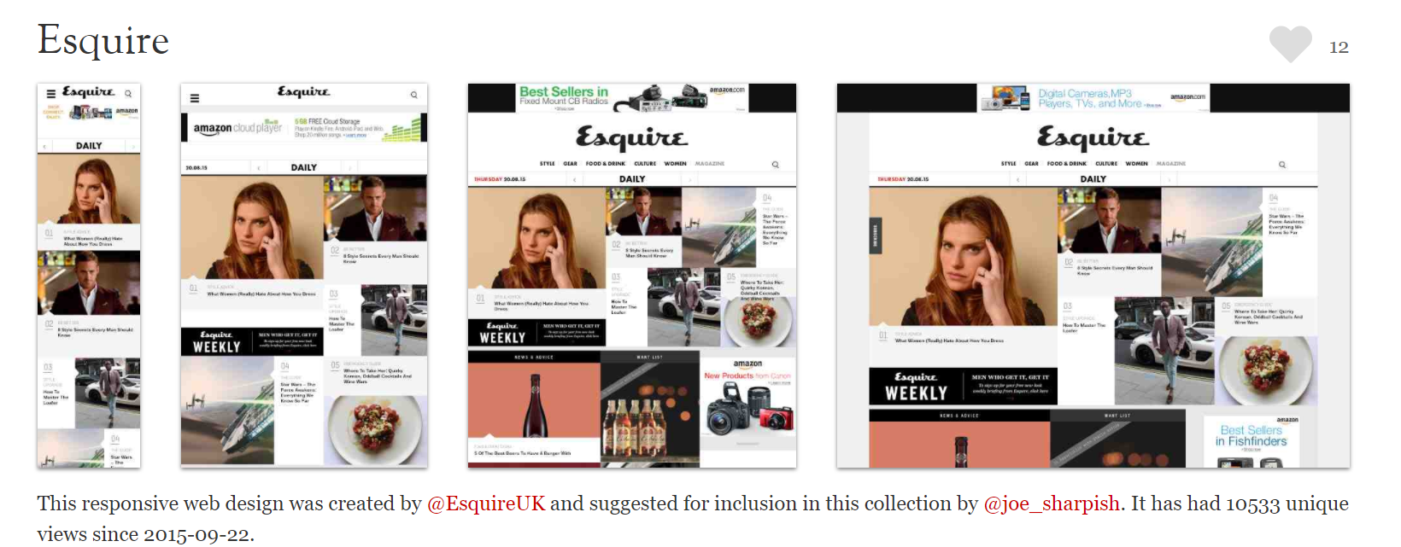

Esquire webpage on different screens

2.4

c. We should use <figure> in addition to <image> tag because <figure> specifies self-contained content. Further more, it has an optional caption and it is a single unit outside the main flow of document and it can be removed without anychange to the document’s meaning. <figure> tag can be used to group all of the images.